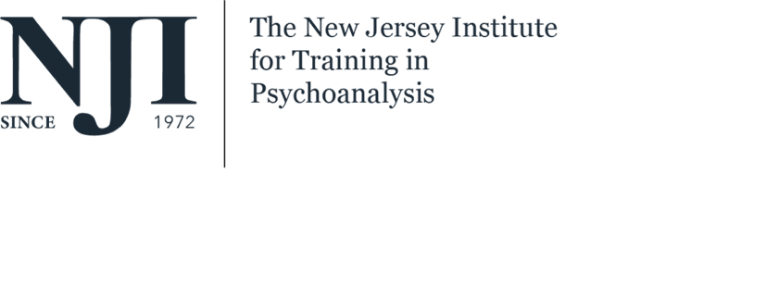

Dear

We are pleased to offer you admissions to our Advanced Psychoanalytic Certification Program
and we welcome you to the NJI community.

We hope that your experience at NJI is an enriching one that helps you grow both personally and professionally.

We are enclosing our admissions offer, please sign it and return it to us at your early convenience.

Please do not hesitate to contact us with any questions that you might have.

I _________________________ accept NJI’s offer of admission to the ___________________

Program.

- I have received the policy booklet outlining the requirements for the program.

- I have been provided with the NJI handbook and a list of possible supervisors.

- I am aware of the following:

Fall Semester Tuition: $350.00 per class plus $115 semester registration fee that includes
PEPWeb library (for one year - paid in the fall) and PACO membership (for one year -paid in the fall)

Spring Semester Tuition: (for returning candidates) $350.00 per class plus $50 registration fee.

Spring Semester Tuition: (for new candidates that begin the program in the spring) $350.00 per class plus $115.00 semester registration fee that includes PEPWeb library and PACO membership.

**Tuition is due before classes begin [when registration closes for each semester].

If you need a monthly payment program, please contact our bookkeeper Christine Everist at chrise4nj@aol.com).

Refund policy: Half of the tuition will be refunded if less than four classes are taken. After four classes, there will be no refund; credit will remain on the account until candidate returns to the Institute.

I am in agreement with the above.

______________________________________________________________________________
Candidate’s signature and date

